HY-460
Database Management Systems

Assignment 02

AM: 3848 DUE: 29/11/2020

ANTONIOS SYKOUTRIS

Task 1. Explore Cache Memory

A.1) In this question we are asked to count the physical reads of some queries. Due to the installation dummy scripts I run in order to check if everything is alright we are starting with 1387 physical reads. That means that any answer will be according to the following equation:

True_Physical_Reads = Output_Physical_Reads – 1.387;

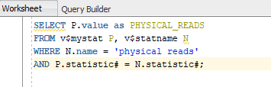
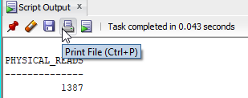

So with that out of the way we are starting with the first query(Physical Disk Reads(Aq1).sql)
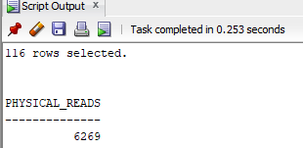
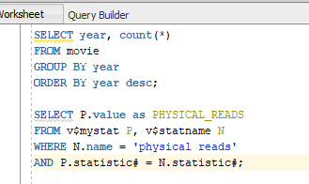

So True_Physical_Reads = 6.269 – 1.387 = 4.882

A.2)
Now its time to do the same exact thing to the second query(Physical Disk Reads(Aq2).sql)

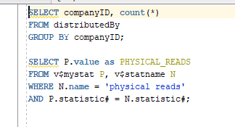


So True_Physical_Reads = 12.237 – 6.269 = 5.968

B.1)

Now its time to find the hit cache ratio of the first query(Cache_Hit_Ratio(Bq1).sql)

By using the equation you gave us and by putting the True_Physical_Reads we find that:

BEFORE AFTER
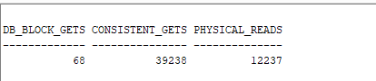


DB_BLOCK_GETS = 68

TRUE_CONSISTENT_GETS = 49.238 – 39.238 = 10.000

True_Physical_Reads = 17.115 – 12.237 = 4.878

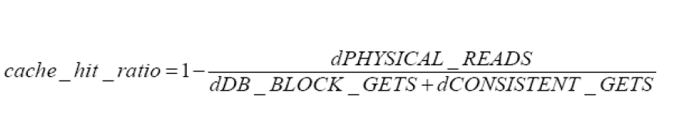
Cache_Hit_Ratio = 51.5% Which is lower that 80% so we need tuning.

B.2)
I will do he same thing for the second query.

BEFORE AFTER
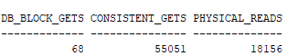
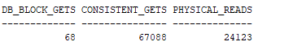

DB_BLOCK_GETS = 68

TRUE_CONSISTENT_GETS = 67.088 – 55.051 = 12.037

True_Physical_Reads = 24.123 – 18.151 = 5.972

Cache_Hit_Ratio = 49.3% Which is lower that 80% so we need tuning.

C)
Now we are asked to calculate the size of the tables in the database (in blocks).To do this I will run the Table_Size_In_Database(C).sql. Below we can see the output of the file I previously mentioned.

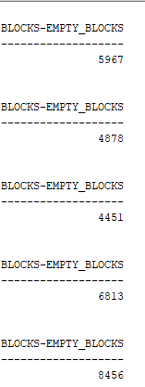
table_name = 'DISTRIBUTEDBY';

table_name = 'MOVIE';

table_name = 'PEOPLE';

table_name = 'PLAYS';

table_name = 'PRODUCEDBY';

So If you put large tables into the cache and use them a lot they will stay there and you will have a more efficient system because it will not ask all the time the disk to bring data. Thats why in order to improve DBMS performance I
think the best choice is the PRODUSEDBY table.

D)

First Query Second Query

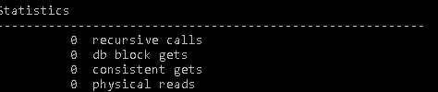
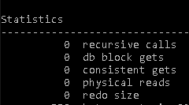

As we can see I have 0 db block(pages) gets because I am reading from the cache(SGA) so it normal for db not to go to ask the disk but get the data from the cache.

Now we should drop the table movie and then proceed to the next task.

Task 2. Explore Indexing Techniques

A)

Below we can see the execution plan for the first query that was given alongside the execution time of it.

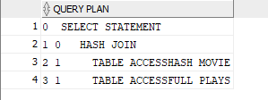
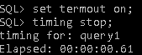

As we can see from the execution time where a taking look a query with a small running time so the differences we can except are negligible. Most of the time the Distinct keyword performs the same and without it but they are few exceptions of running faster or slower.

Now the same thing will be running again but now we will put the DISTINCT statement in the query.

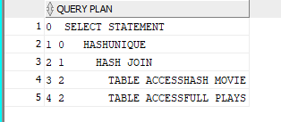
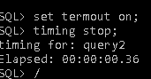

This result is showing us that using Distinct we are putting in explain plan HASHUNIQUE. To do that(to remove duplicates first the optimizer has to track them. Using Google to find how it does that, I came to the conclusion that it uses very advanced algorithms in order to make it as fast as possible so it does not slow down that much the query. This can be verified because the difference in running times of the above queries it is small.So without having to deal with the duplicates in this case we are faster using Distinct.

B)
Now we were asked to create a cluster at first and then drop and create again the Movie table. After that we should insert again the values and then identify again the execution plan and the execution time. Below there are the 2 screenshots.

PLAN_TABLE

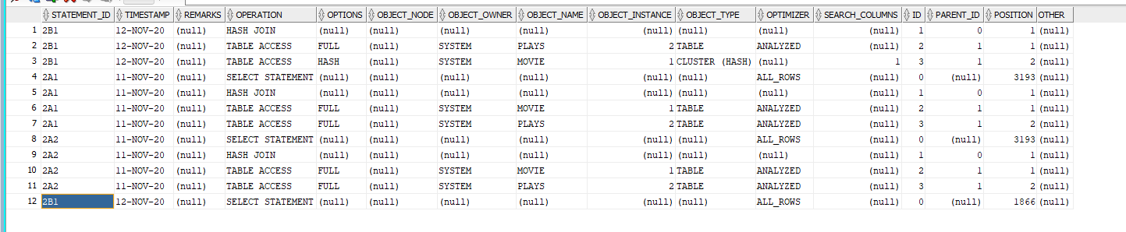
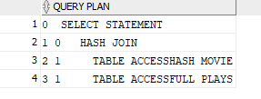

After

EXECUTION TIME

Which is lower that the previous execution(without the cluster)

EXEC_IMPROVEMENT = OLD_EXEC_TIME - NEW_EXEC_TIME

EXEC_IMPROVEMENT = 00:00:00.36

So by using hash cluster AND by using the correct queries we can speed up a lot the execution time of a query because we can easily find the data of a search using hash clusters.

C)
Now we had to drop the PLAYS table then relate the field movieID with the cluster generated in B and after that show the execution plan and the execution time.

PLAN_TABLE

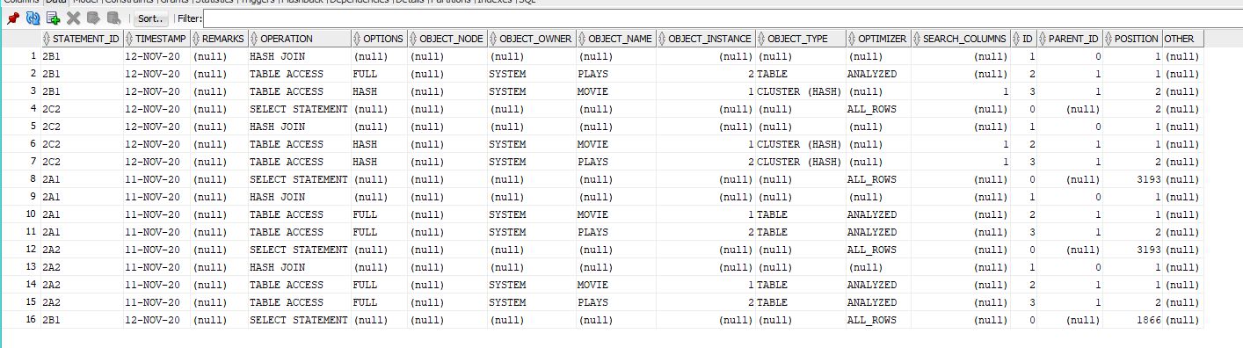

EXECUTION TIME

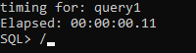

Again the execution is faster for the reasons I mentioned in B

D)
Now we had to find the execution plans for the given queries(Task_2(D.1).sql , Task_2(D.2).sql).

For the first Query

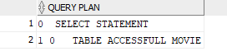

For the second Query

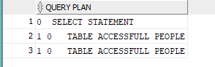

Observation:Both of those queries did a full table scanning to give the appropriate answers. That is not necessary a bad thing if the query if very fast but if it takes a long time to execute then there is a problem with that.

Now we have to create a unclustered B+-Tree for the year field of the table MOVIE.We except the newly created explain table not to do a full scan but it might also do one if the query optimizer thinks that is easier to just read the whole table rather than looking for the relevant rows, then picking them off the disk.

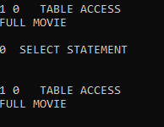

It is analyzed but still the optimizer prefer to ignore the index and perform a full table scan even tho I have analyzed it and correctly made the index.

Now we have to create a unclustered B+-Tree for the birthYear field of the table PEOPLE.
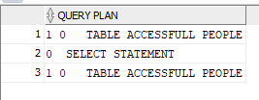

The same thing as above happened. It completely ignored the index and due to reading the lectures and searching online this actually can happen quite often and only if it is a must the full table scan will be replaced by the index.

To prove my point I did a select query using a hint in order to force the index activation. Below there are the results of my action.
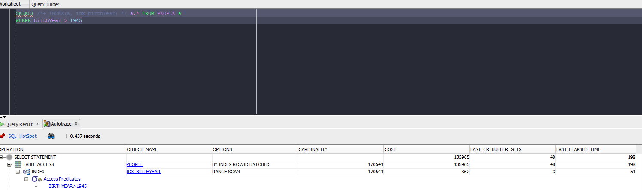

Because it made a RANGE scan, it means that the Cost Based Optimizer doesn't think the index is very useful. So that's why it makes a full scan instead.(I also put a Dracula theme on SQL Developer because I hate light themes).

E)
For this question I used(Task_2(E.1).sql , Task_2(E.2).sql).

First Query Second
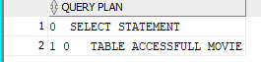

As we can see it shows a full table access in the first query but in the second one it uses Hash not full so it uses the index of B+-Tree because it is performing a range scan and for range scan B+-Tree is very beneficial.

F)
In this question we should make a new index for the movieTitle field (idx_movieTitle).To do this I used the file(Task_2(F).sql).

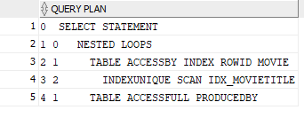

As it can be seen it used the idx _ movieTitle(so the non cluster was being used) because we put 2 tables data inside the same block (MOVIE,PRODUSEDBY) and if its is under heavy data retrieval unclustered indexes can speed up a lot the searching process(we are not scanning with pk so the search would take a lot of time without index).

G)
Now we are asked to run the query that was given and after that to produce the explain plan and also calculate the execution time.
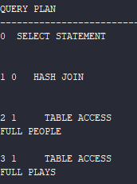

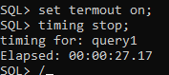

(i)Now I drop the idx_birthYear and repeat the above actions

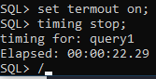
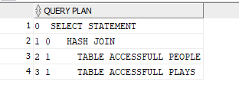

As we can see from the screenshots above we were having 5 seconds less when we didn’t have the idx_birthYear.

(ii)Now I have to create a bitmap index on the birthYear field and repeat the above actions.

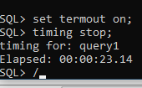
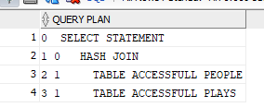

As we can see (ii) is slightly slower than (I) but faster than the first(G).The reason for that is because bitmap uses a lot of resources to be able to function so that's why we see the small performance loss.On the other hand one huge advantage of using a bitmap index over a b+tree index is storage(it is less storage hungry).

H)
In the last question we are asked to define a clustered B+-Tree on the birthYear field. Afterwards we should drop the People table and then execute the query of G.
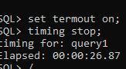
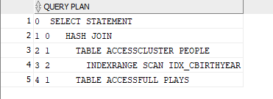

As we can see if we compare the 2 explain plans we can see(row 3 was added) that because we are performing a range scan on a non primary key value clustered B+-Tree index was used in order to improve performance. We can also see that it is faster than the unclustered B+-Tree index because the unclustered one must duplicate values in order to map them with pointers(known as overhead cost) and that cost is responsible for the difference of speed we are experiencing. If we had made an insert here instead of search unclustered would be faster because we would just need to map the new insertion with a pointer rather than having rearrange the data.

Thanks a lot for reading my report and stay safe.

